LINK per l’indagine da condividere con gli studenti:

PRE-INTERVENTO

https://forms.gle/a8wPkt4HiEANxYMx8

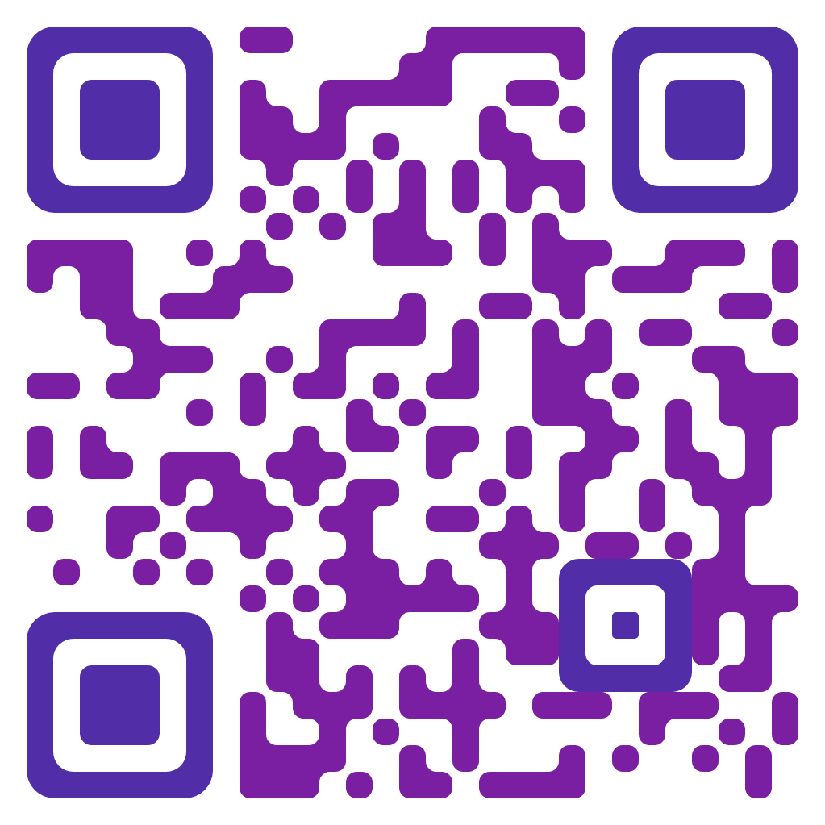

POST-INTERVENTO

https://forms.gle/4Tisnrkty5qnMT8f8

